System Analysis and Design

Document history

|  |  |  |  |  |
| --- | --- | --- | --- | --- |
| Version | Date | Author | Changes | Valid from |
| 1.0 | 24-Aug-2016 | Hardik Kansara | Draft | 28-Aug-2016 |

Table of Contents

1. Introduction 3

1.1 Purpose 3

1.2 Scope 3

2. Process Model 4

3. Technical Architecture 6

3.1 System Architecture 6

3.2 Technical Architecture Design 6

3.2.1 Use Case Diagram 6

3.2.2 Class Diagram 7

3.2.3 Erd Diagram 9

3.2.4 Activity Diagram 10

3.2.5 User Interface – Navigational Paths and Screen Mock-up 11

3.3 System Development/Testing Environment 12

3.3.1 Development Environment 12

3.4 Security 13

3.5 Performance 13

# 1. Introduction

## 1.1 Purpose

The project team want to attract SME (Small and Medium-Sized Enterprises) who has implemented SQL server in their infrastructure and want to know the implementation risk and verify the configuration of databases and SQL Server. The biggest opportunity with this project are first customer can see what parameters are missing with the exiting database implementation. Large number of SQL Server instances auditing is also very easy perform by this tool.

Customer will get the benefit of an audit report to tune their database parameters in well advance to overcome all the security and performance problems. Sometimes it will costly for a small business to hire a professional or a contractor to evaluate their database system because it is time consuming and costly process.

Therefore, this tool is also for a business or a customer who may not be able to hire a full time database administrator to diagnose their database system.

## 1.2 Scope

The project team will be responsible to deliver the final products for this project which are as follows:

1. A website from where a customer can download the client application and upload the database dump files.
2. A client application that will produce a dump file of the client’s database with exiting parameters values only.
3. A database evaluator tool that will generate reports from the dump files uploaded by customers.

# 2. Process Model

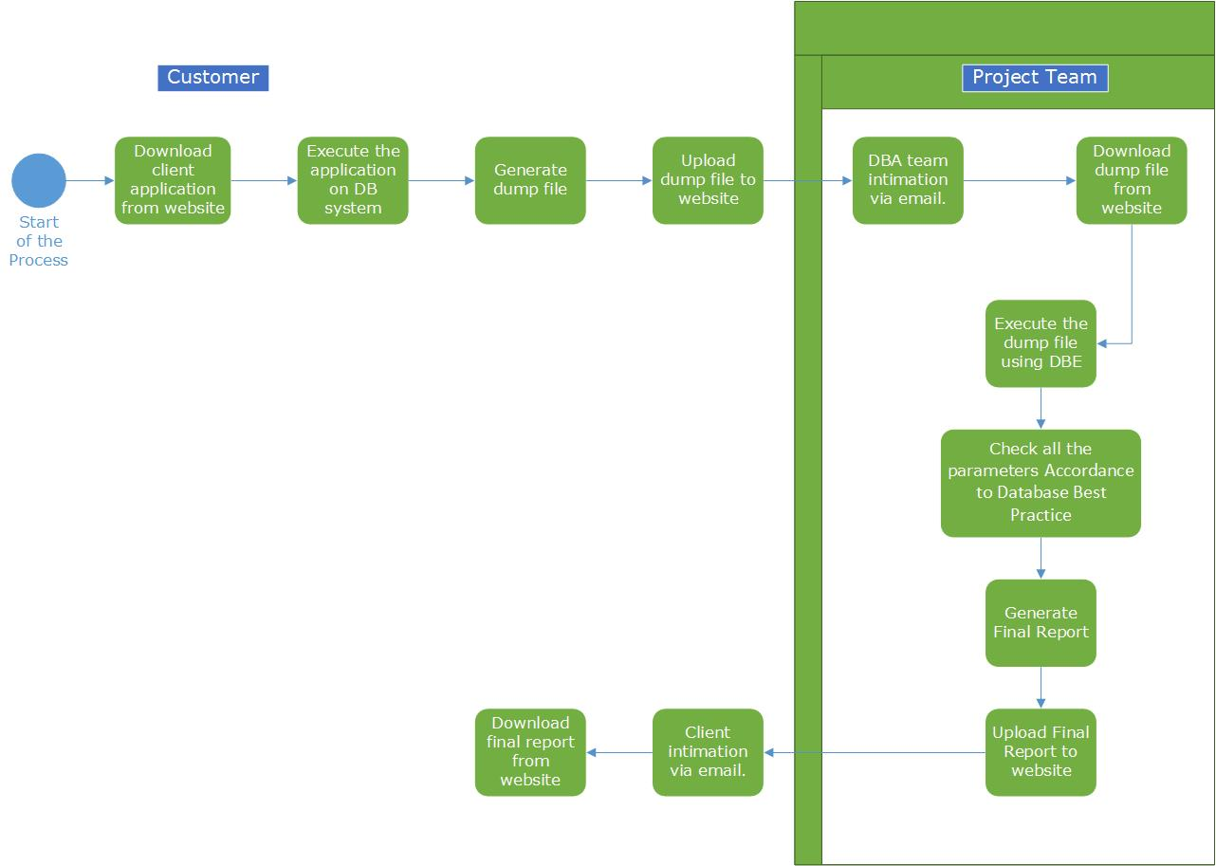

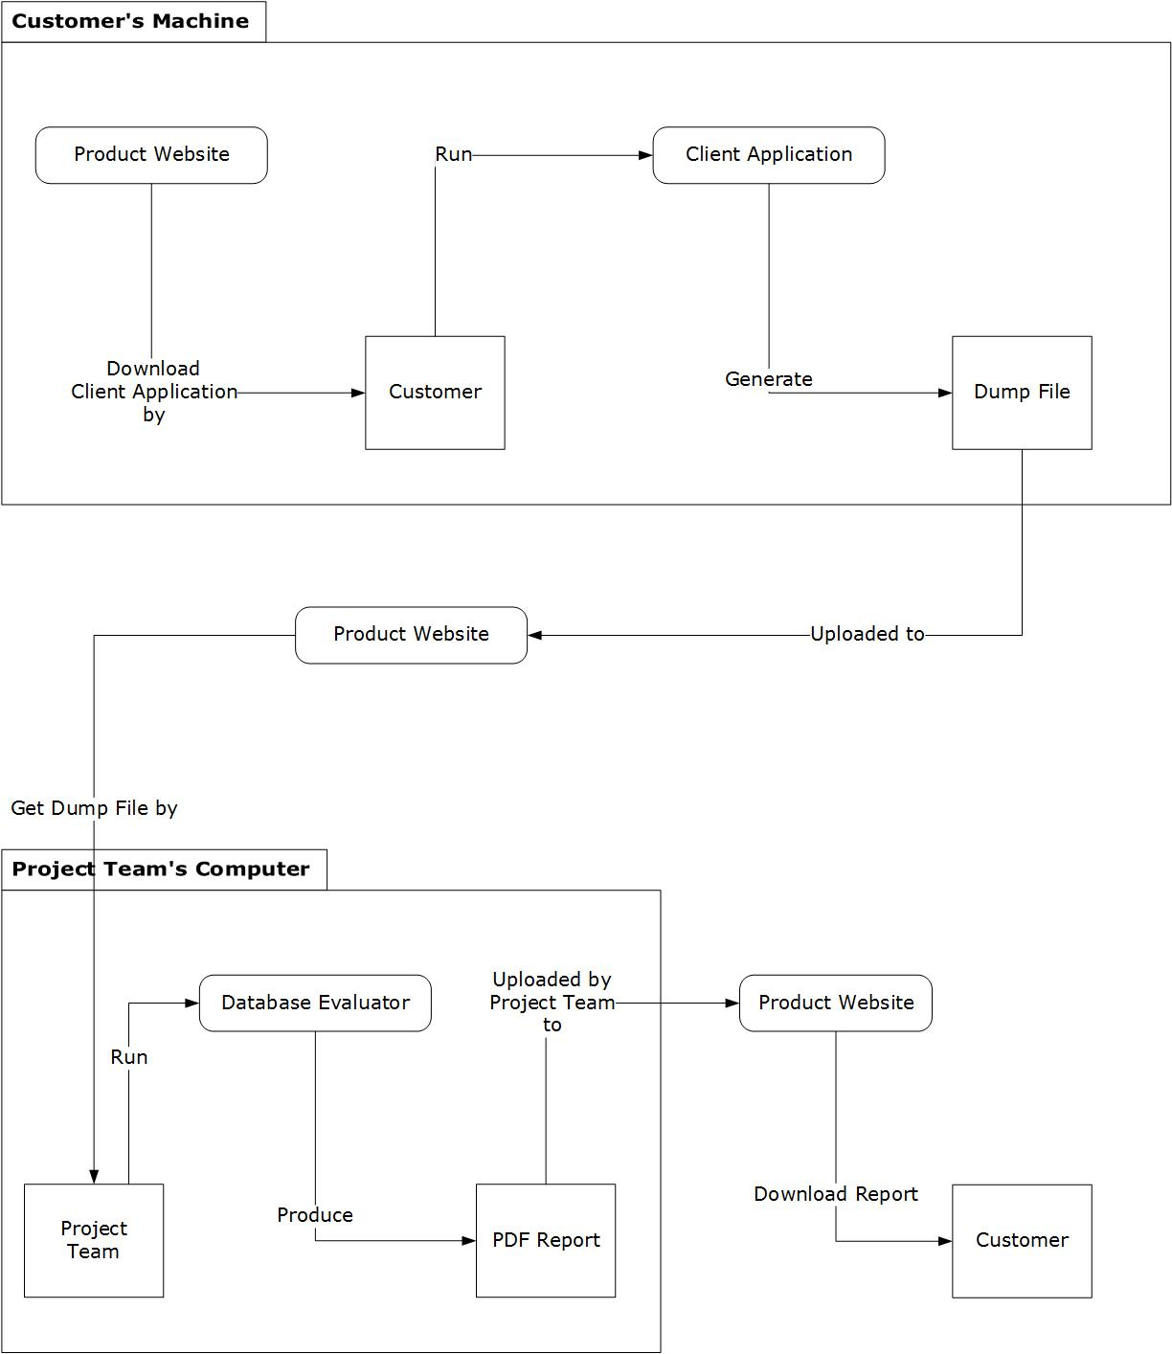

# 3. Technical Architecture

## 3.1 System Architecture

| **System Architecture Location** | C:\Users\Hardik\Documents\GitHub\Weltec-Project\1. Final Documentation\4. DSDM Documents\3. Faoundations\ SystemArchitectureDefinition.doc |
| --- | --- |

## 3.2 Technical Architecture Design

### 3.2.1 Use Case Diagram

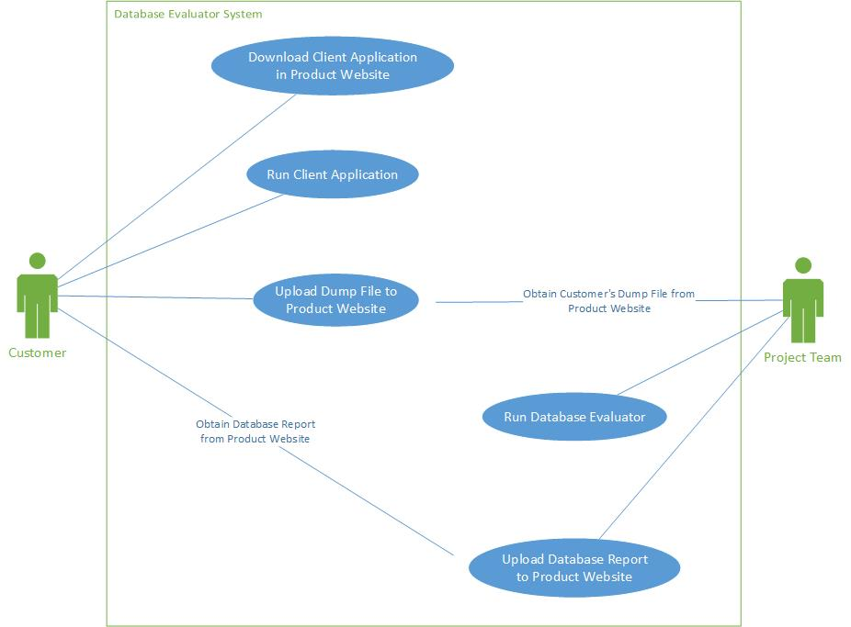

### 3.2.2 Class Diagram

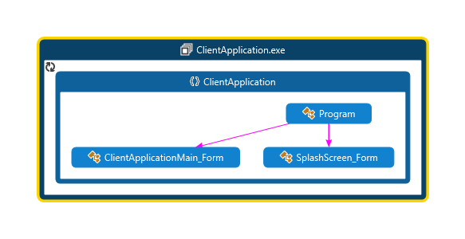

|  |  |
| --- | --- |
|  |  |

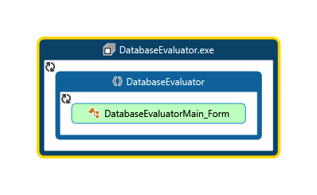

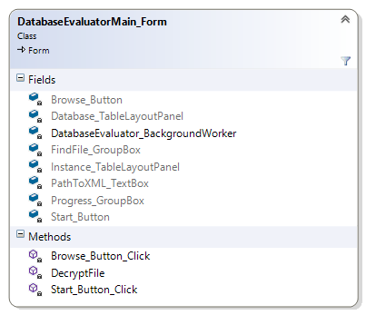

### 3.2.3 Erd Diagram

Database Evaluator Table



Website



### 3.2.4 Activity Diagram



### 3.2.5 User Interface – Navigational Paths and Screen Mock-up

**Client Application**

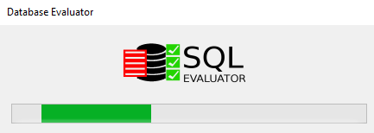

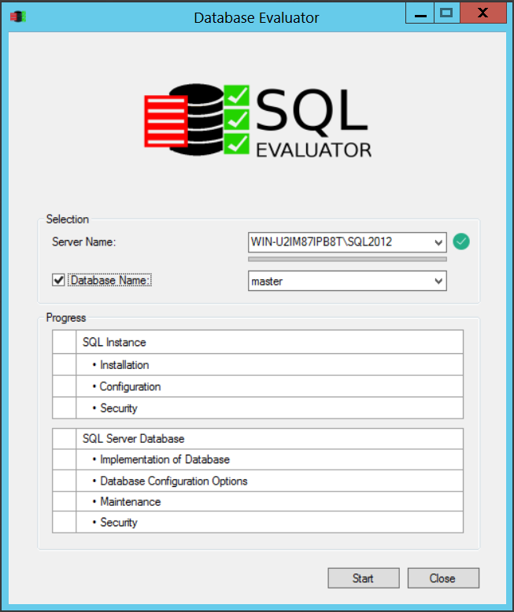

**Database Evaluator**

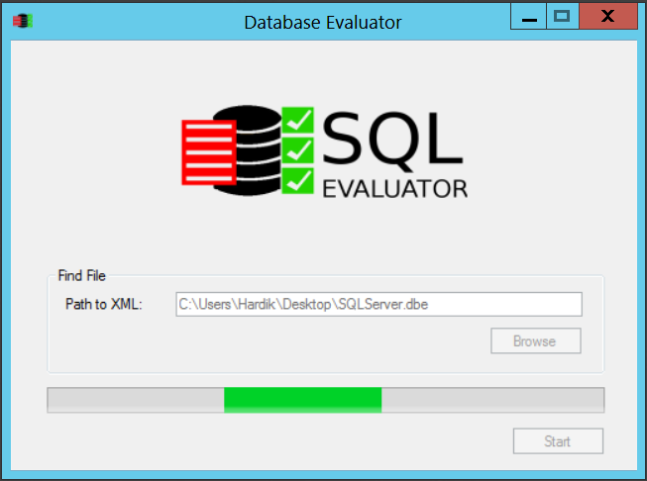

**Final Report Example**

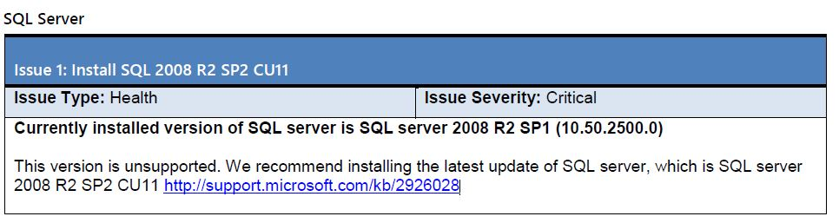

## 3.3 System Development/Testing Environment

* Client application and database evaluator will be developed in C#.
* SQL Server 2008 R2 and SQL Server 2012 will be used for creating database, generate and test SQL script.
* Website will be created using a Wordpress, PHP and MySQL.

### 3.3.1 Development Environment

Microsoft Visual Studio Enterprise 2015 Update 1

Eclipse for PHP Developers Release 4.5.2

XAMPP for Windows Version 5.6.21

PHP 5.6.21

phpMyAdmin 4.5.1

MariaDB 10.1.13

Apache 2.4.17

Git version 2.9.2

Install Shield 2015 Limited Edition

SQL Server 2016

SQL Server 2016 Management Studio

## 3.4 Security

It is planned that dump file will be encrypted for security purposes. Client application will not modify any existing parameters on customer database system.

The Website must implement basic security behaviours:

• Authentication: Login using at least a user name and a password

• Authorization: according to their profile, online customer must be granted or not to perform some specific actions. (Upload Dump File and Download Final Report)

For internet access, the following requirements are mandatory

• Confidentiality: sensitive data must be encrypted (credit card payments)

• Data integrity: Data sent across the network cannot be modified by a tier

• Auditing: Every sensitive action can be logged

• Non-repudiation: gives evidence a specific action occurred

C# and WordPress security model will be reused.

## 3.5 Performance

* Client application collects the parameter values without any error and modifying existing values.
* Encrypted dump file will be uploaded on website without any error.
* Database Evaluator will check and produce the final report without any errors.